COFFEE SHOP SALES ANALYSIS DASHBOARD USING POWER BI – WEEK 3

Week 3 Report: Advanced Visualization Techniques and Interactive Reporting

Submitted By: Jonnalagadda Venkata Naga Vishnusri

Internship: Virtual Power BI Data Visualization Internship

Organization: Henry Harvin Education in collaboration with YuvaIntern

Dataset: Coffee Shop Sales Dataset (Maven Analytics)

Submission Date: 13 August 2026

Project Title: Coffee Shop Sales Analysis Dashboard using Power BI – Week 3
Table of Contents:
- Introduction
- Dashboard Objective
- Dashboard Layout
- Visualization Used
- Interactive Elements
- User Experience
- Business Insights
- Conclusion

- Introduction:
Advanced Coffee Shop Sales Dashboard was created using Microsoft Power BI to analyze sales performance through interactive and advanced visualizations. The dashboard presents key business metrics, product category performance, sales trends, store-wise sales, and top-performing products. Interactive slicers are included to allow users to filter the dashboard and analyze the data from different perspectives.

- Dashboard Objective:
The main objective of the dashboard is to provide a clear and interactive view of coffee shop sales performance. It helps users identify important trends, compare product categories, analyze store performance, and understand which products generate the highest sales.

- Dashboard Layout:
The dashboard is organized into different sections:
- Header: Advanced Coffee Shop Sales Dashboard.
- KPI Cards: Total Sales, Total Transactions, Total Quantity, Average Unit Price and Distinct Products.
- Left Side: Interactive Slicers.
- Upper Section: Product Category Sales and Sales Trend.
- Lower Section: Store Location Sales and Top 10 Products.
This layout keeps the dashboard organized and makes important information easy to find.
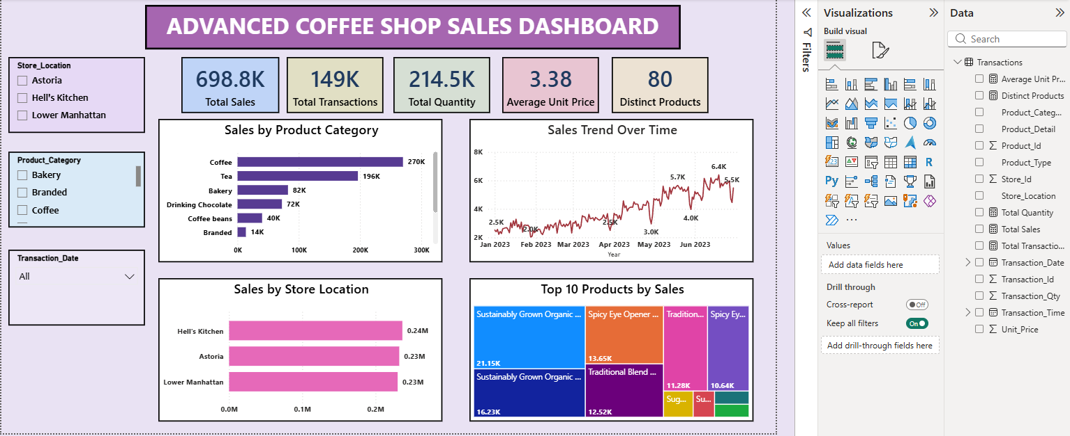
Figure 1: Advanced Coffee Shop Sales Dashboard

- Visualizations Used:
- Sales by Product Category – Clustered Bar Chart:
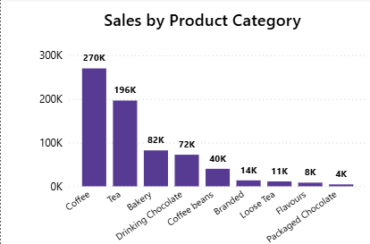
This chart compares total sales across different product categories. It helps identify the highest and lowest performing categories.
Figure 2: Sales by Product Category

- Sales Trend Over Time – Line Chart:
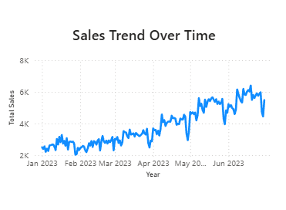
This line chart shows how sales changed over time. It helps identify growth patterns, fluctuations and important changes in sales performance.
Figure 3: Sales Trend

- Sales by Store Location – Bar Chart
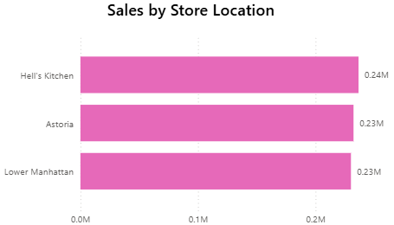
This visualization compares sales across different sales locations and helps identify better-performing locations.
Figure 4: Sales by Store Location

- Top 10 Products by Sales – Tree Map
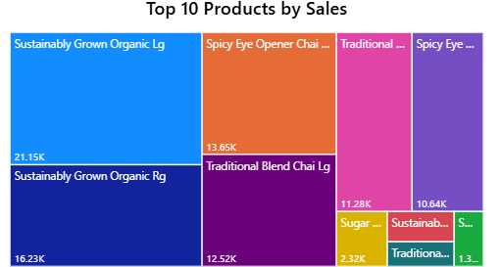
The tree map displays the top-selling products using different-sized blocks. Larger blocks represent products with higher sales.
Figure 5: Top 10 Products

- Interactive Elements:
The dashboard contains three main slicers:
- Store Location.
- Product Category.
- Transaction Date.
Users can select values from these slicers, and the charts and KPI cards update accordingly. This allows users to perform focused analysis without changing the dashboard structure.
Figure 6: Interactive Slicers for Store, Product Category and Transaction Date.
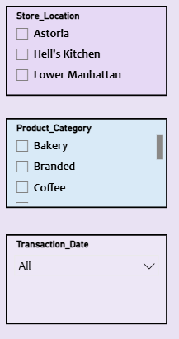

- User Experience:
The dashboard uses consistent colors, clear titles, KPI cards and properly arranged visual elements. The interactive filters make it easy for both technical and non-technical users to explore the data.
- Business Insights:
The dashboard shows that Coffee and Tea are the highest performing product categories by sales. Sales show an overall increasing trend over time, with some fluctuations. Hell’s Kitchen has slightly higher sales compared with Astoria and Lower Manhattan. The Top 10 Products view also helps identify the products contributing most to overall sales. These insights can help decision-makers focus on high-performing categories, products, and store locations.
- Conclusion:
The Advanced Coffee Shop Sales Dashboard demonstrates the use of Power BI for interactive reporting and advanced data visualization. By combining KPI cards, charts, a tree map, slicers and time-based analysis, the dashboard provides an effective way to explore sales data and support data-driven business decisions.

